County of

CA

RE: ,
SC:
NA:

Subject: Recommendation NOT to extend commitment

Pursuant to Penal Code Section 2972 please find DSH-Napa’s recommendation that [First Name] [Last Name] should not be considered for an extension of this commitment.

DSH-Napa is requesting notification from the court when the matter has been calendared. Please email any minute orders to Napa State Hospital, Attn: Forensic Services, Legal Records via email to NSH.CourtDocuments@dsh.ca.gov or fax to (707) 254-2321.

Sincerely,

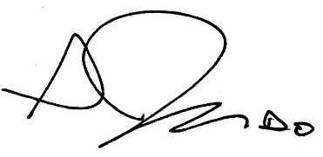
Seth Judd, D.O.
Medical Director, or Designee

cc: Health Information Management Department, Unit Chart, Program File, CONREP

A F F I D A V I T

I, the Medical Director of Napa State Hospital, have legal responsibility for the care and treatment of [Click & type] [Click & type], NSH#[click & type] County Superior Court # [click & type the court number].

I have reviewed the case and it is my opinion that the above-named individual does not qualify for continued commitment under Section 2972, California Penal Code.

Therefore, I am recommending to the prosecuting attorney that an application for extension of commitment not be made.

I declare under penalty of perjury that the foregoing is true and correct to the best of my knowledge.

Seth Judd, D.O.
Medical Director, or Designee

